**Create a simple ContactList Android app**

Create a simple ContactList App supporting both phones and tablets by fetching json data.

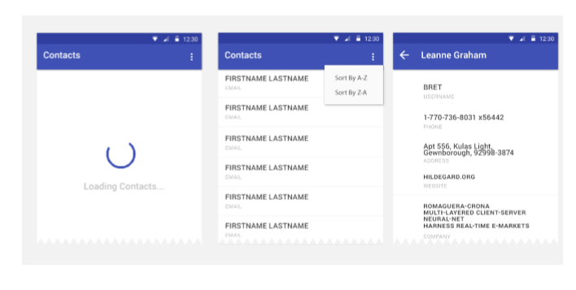

Requirements:

- Support Android 4.0+

- Support portrait and landscape screen orientation

- Use the list of people fetched live from <https://gist.githubusercontent.com/anonymous/fdd533a70291d306a997503f85189f71/raw/81f682fa5a0572bdd8226a4a1e9b64de1dad90cd/blob.json>

- Loading progress dialog when fetching the list

- List can be sorted alphabetically (Ascending & Descending)

- Use volley for json parsing and don’t worry too much about the exact coloring.

- Single pane view for phone [Listview and detailed view in 2 screens as shown in above figure]

- Two paned detailed view for tablets- [Sample screenshot for tablet view below ; no image block is there in deatiled pane for this project] - [Mandatory]

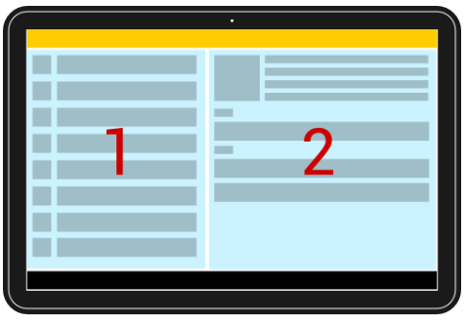

Note: Please send the completed project only, partially done projects wont be appreciated..

Thanks!!

John.